1. Add Employee
2. Add Employee URL
3. Validation on Create and Update Request data
4. View Employee
   1. Exceptional Handling View Emp
5. Update employee
6. Exceptional Handling Upd emp
7. Delete employee
8. Exceptional Handling Del emp
9. View all employees
10. ExceptionalHandling if no Emp in the table
11. Database Exception
12. Content - Negotiation
13. Logging
14. Externalized Configuration
15. Profiling
16. Actuator

Add employee

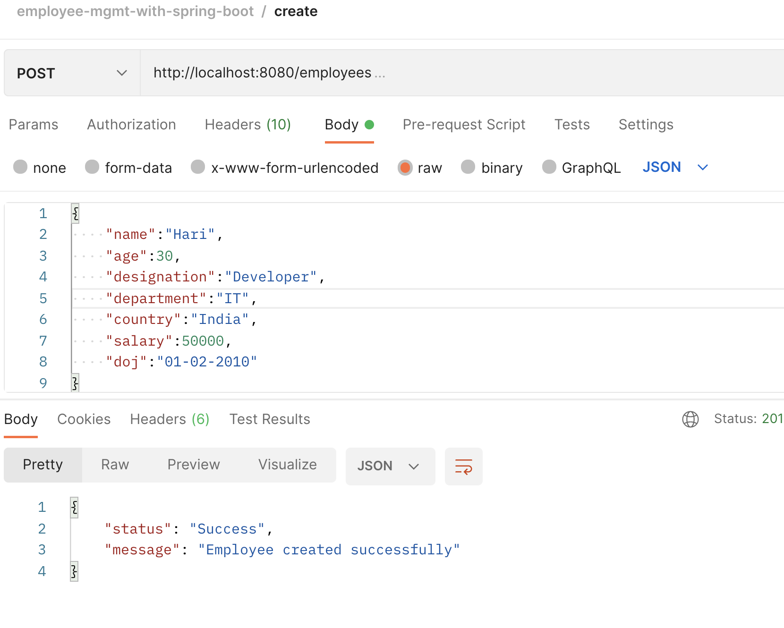

Add Employee URL

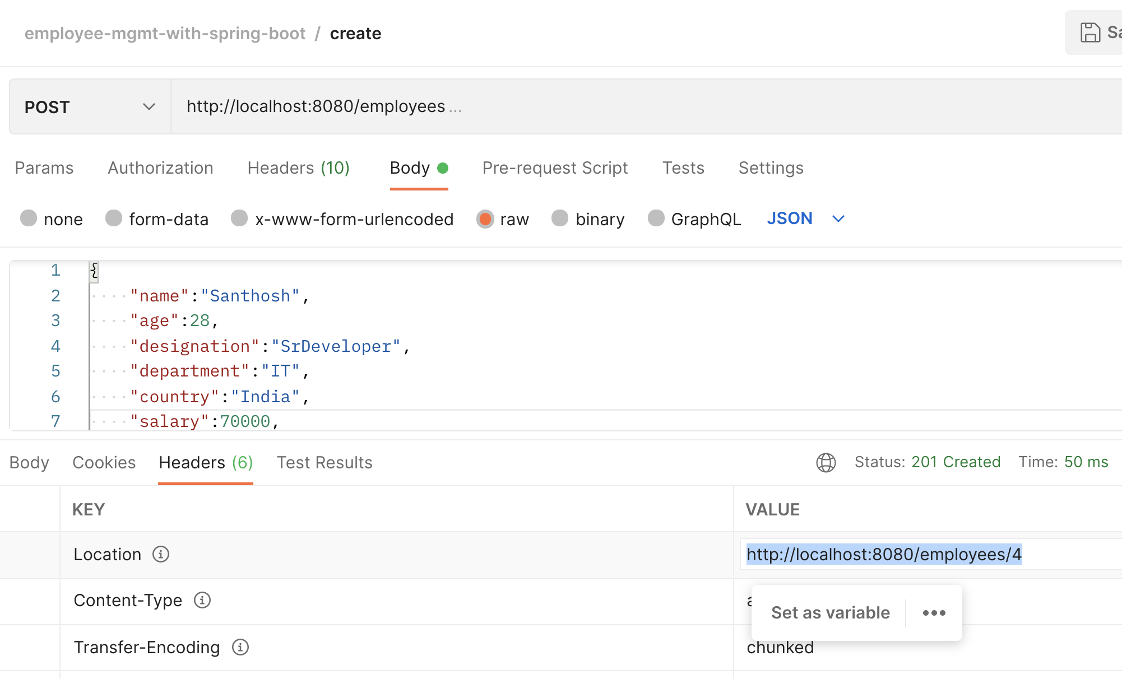

Validation on Create and Update Request data

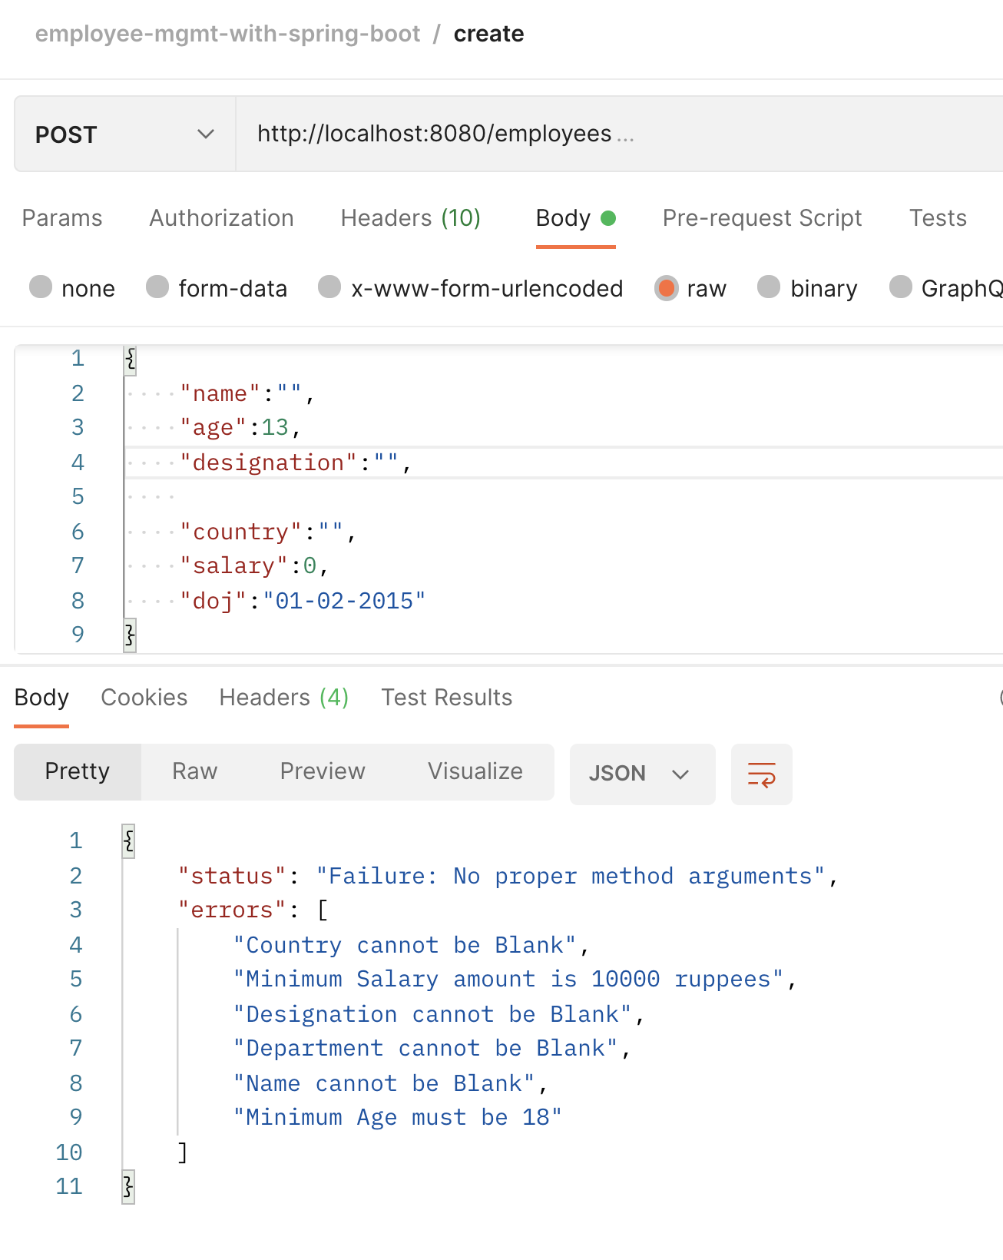

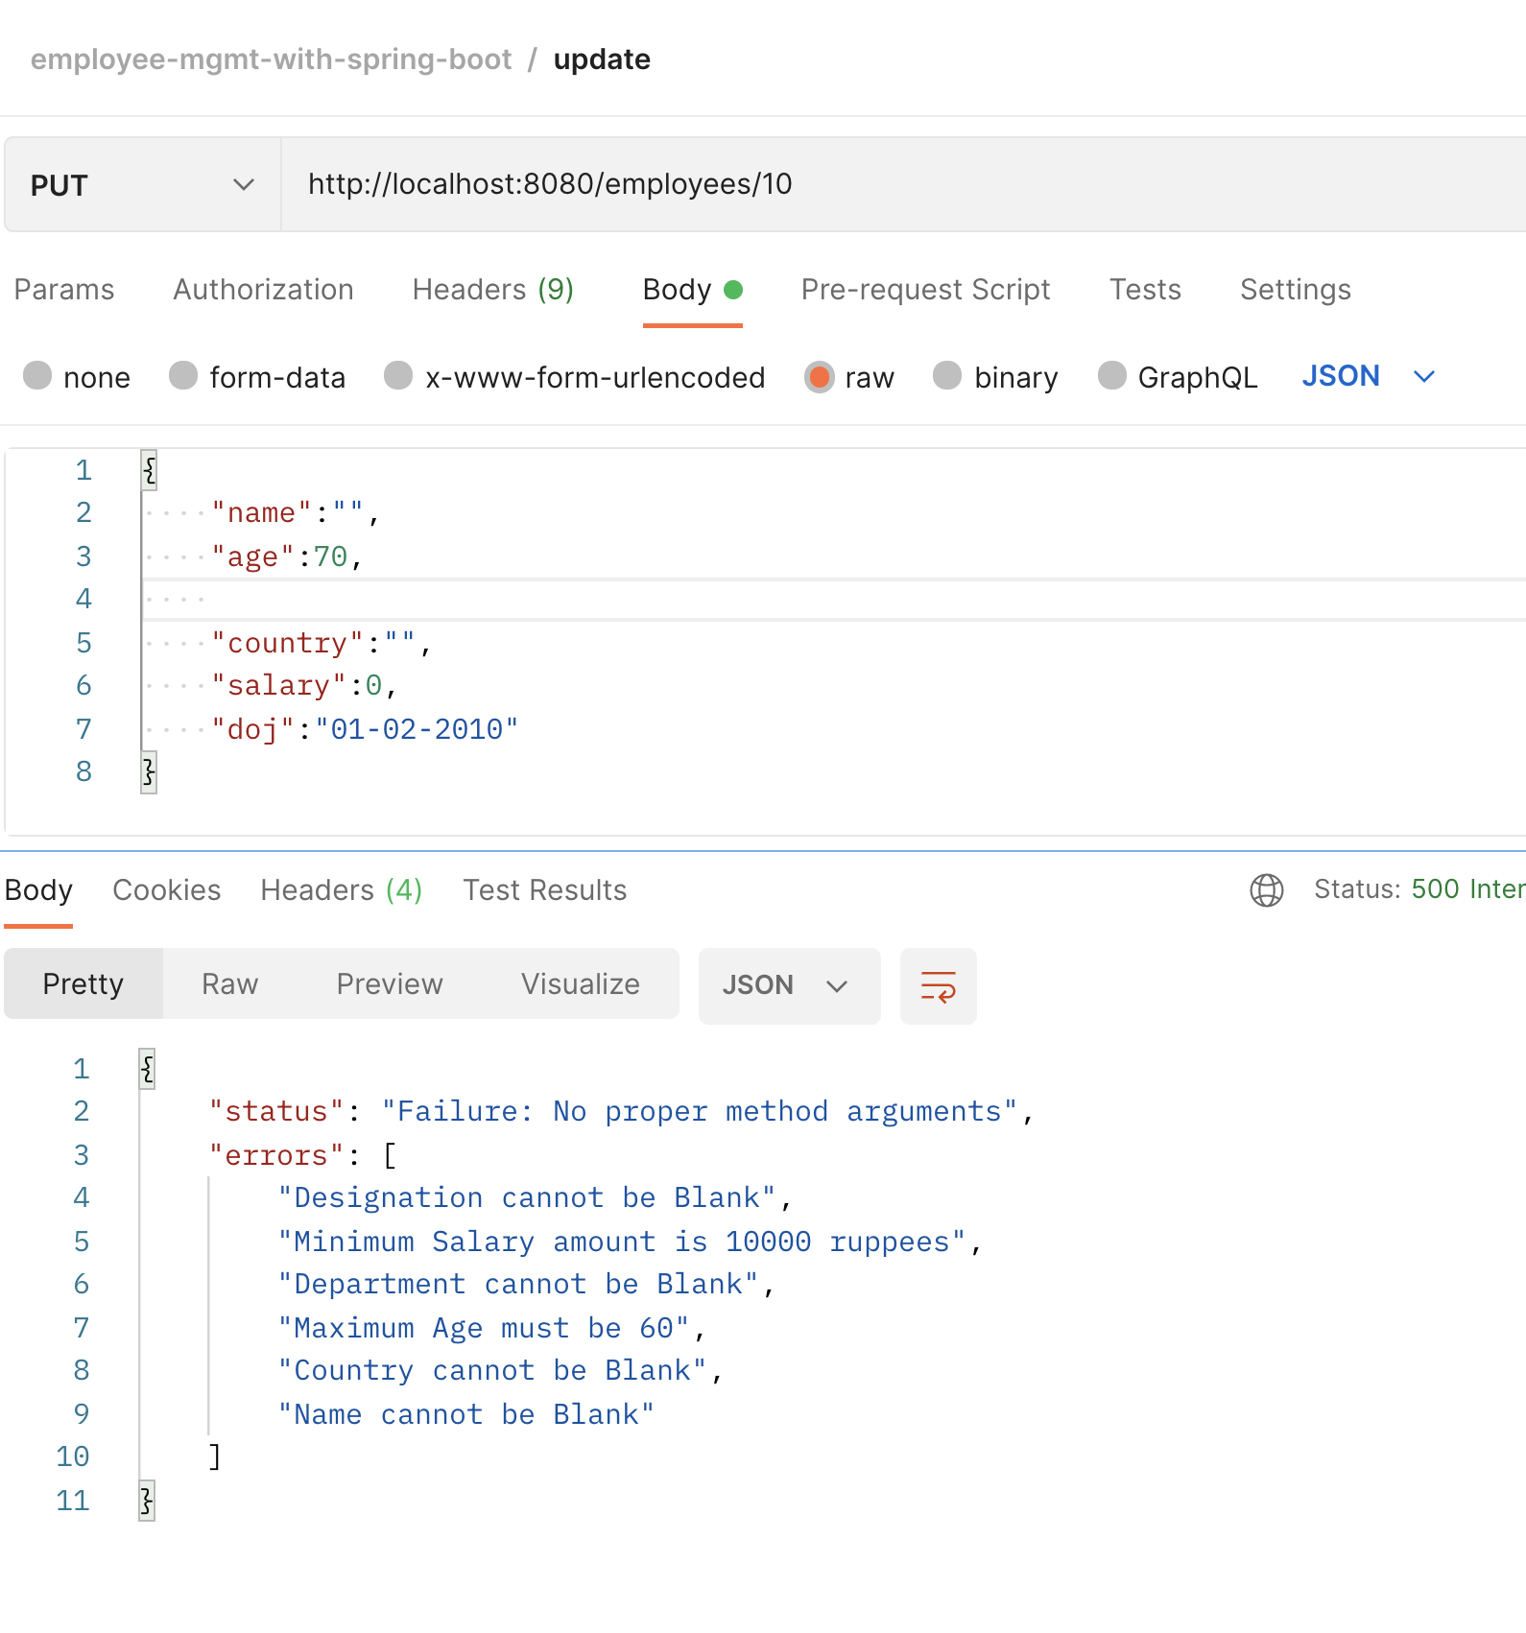

View Employee

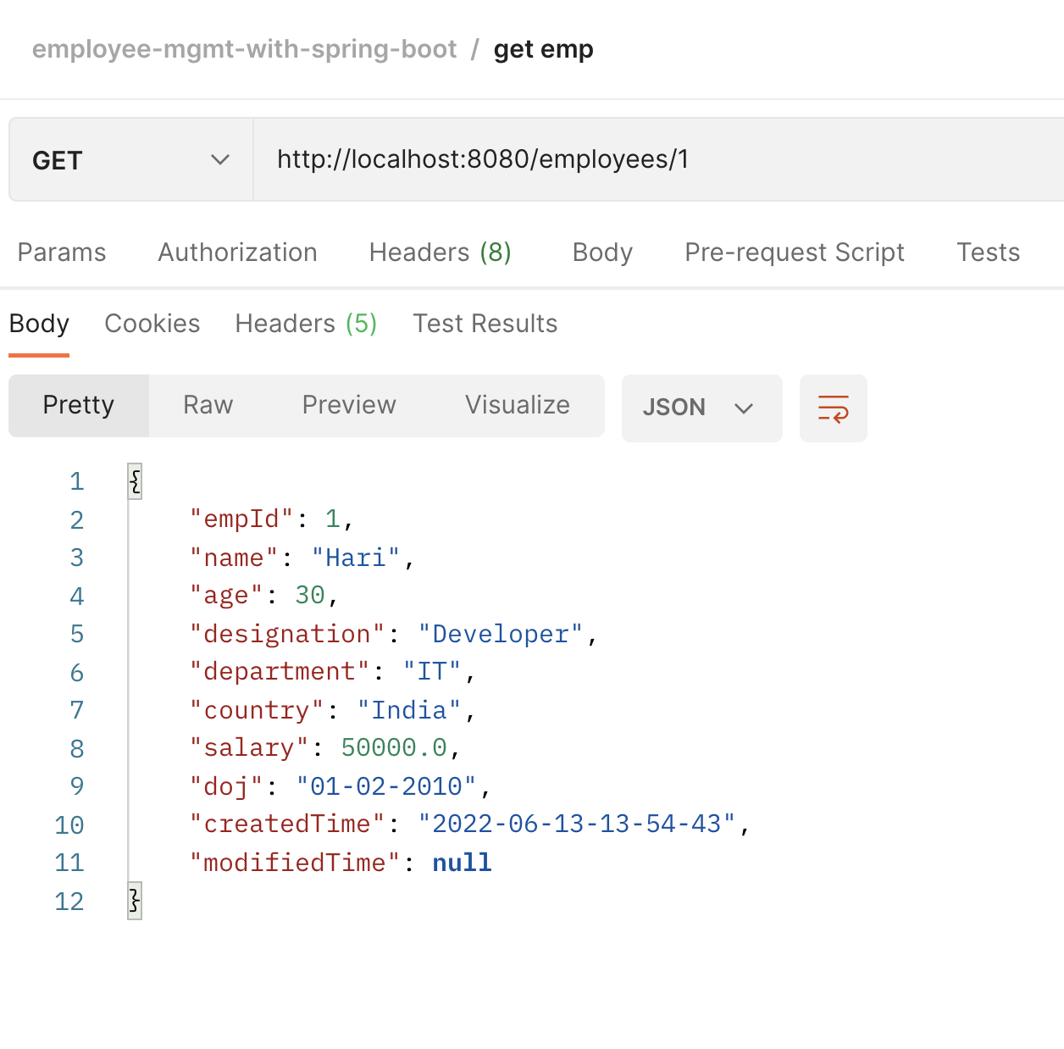

Exceptional Handling View Emp

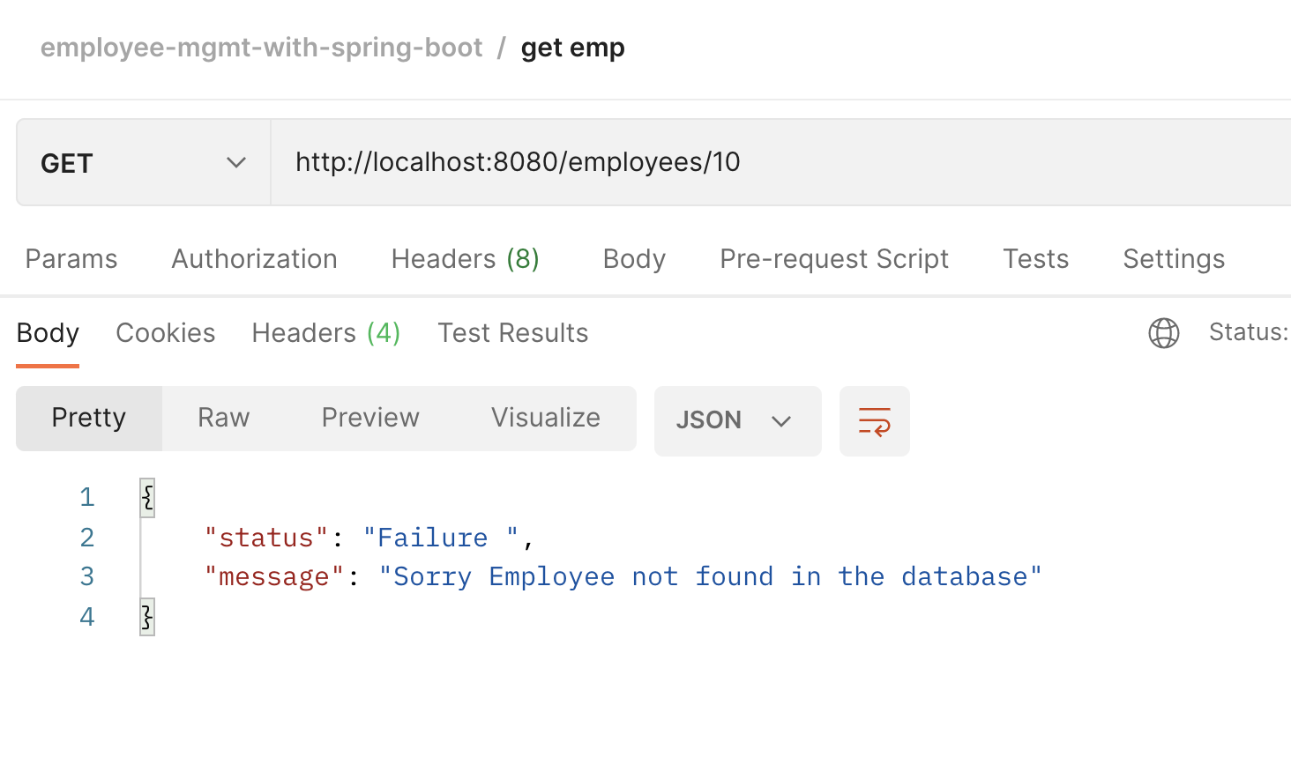

Update employee

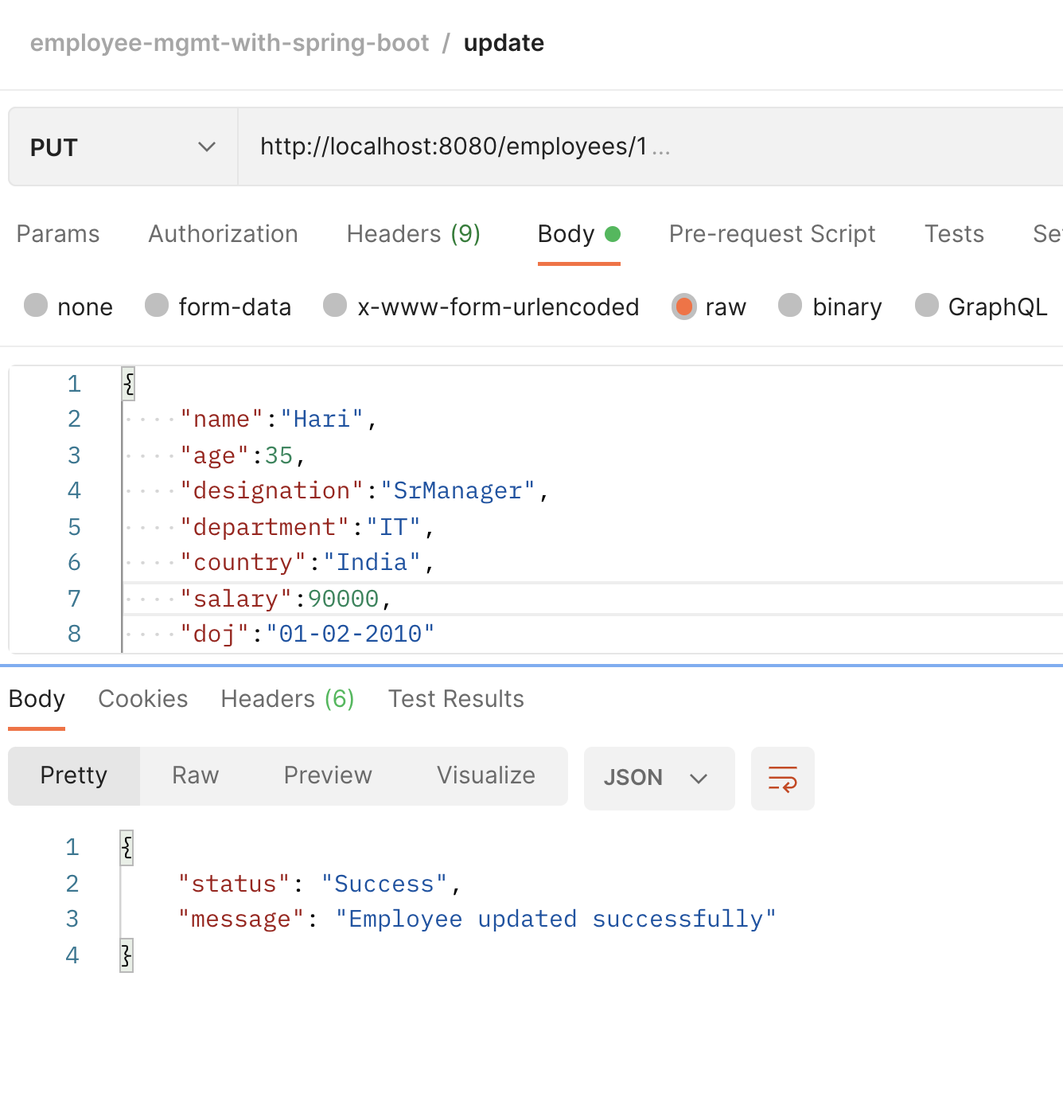

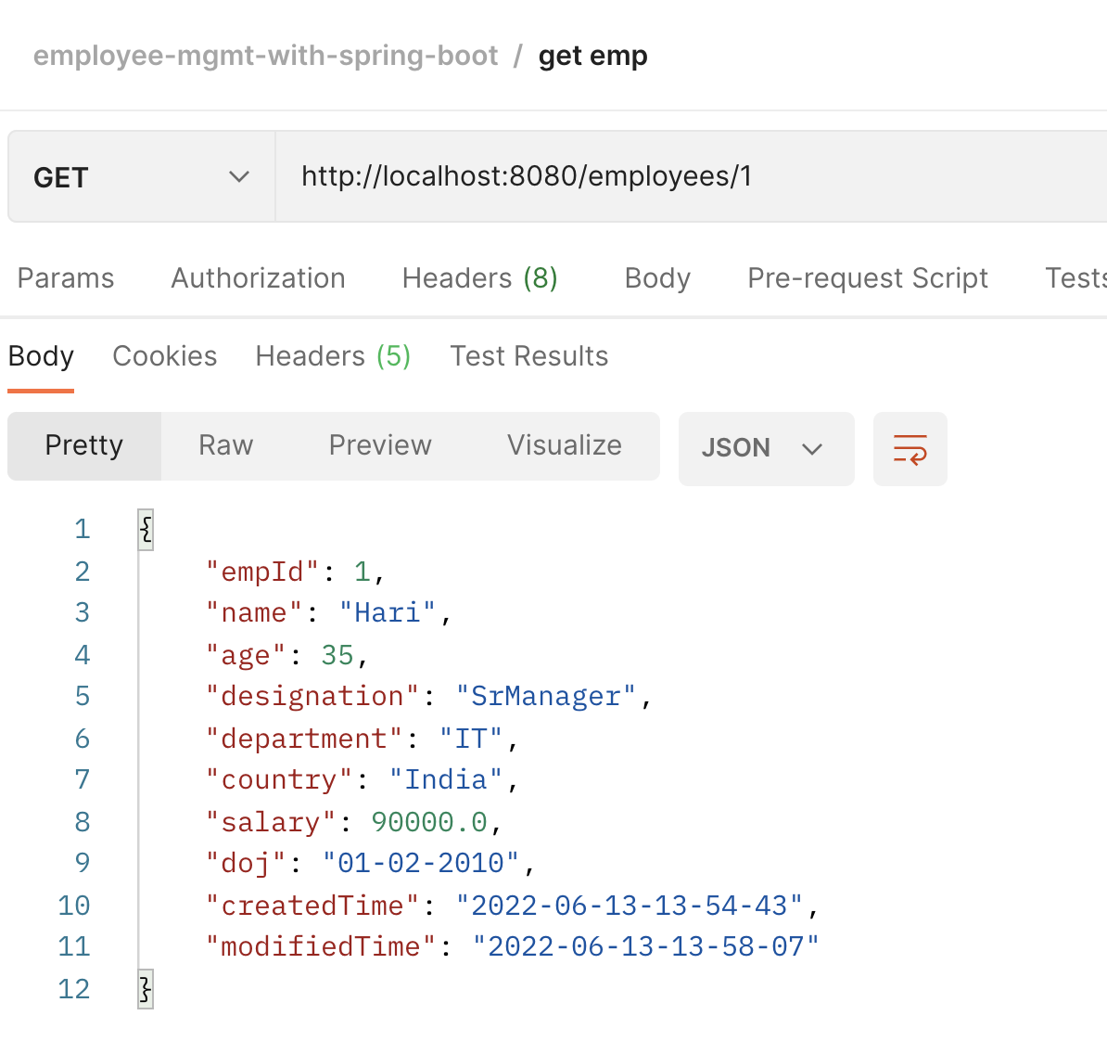

Exceptional Handling Upd emp

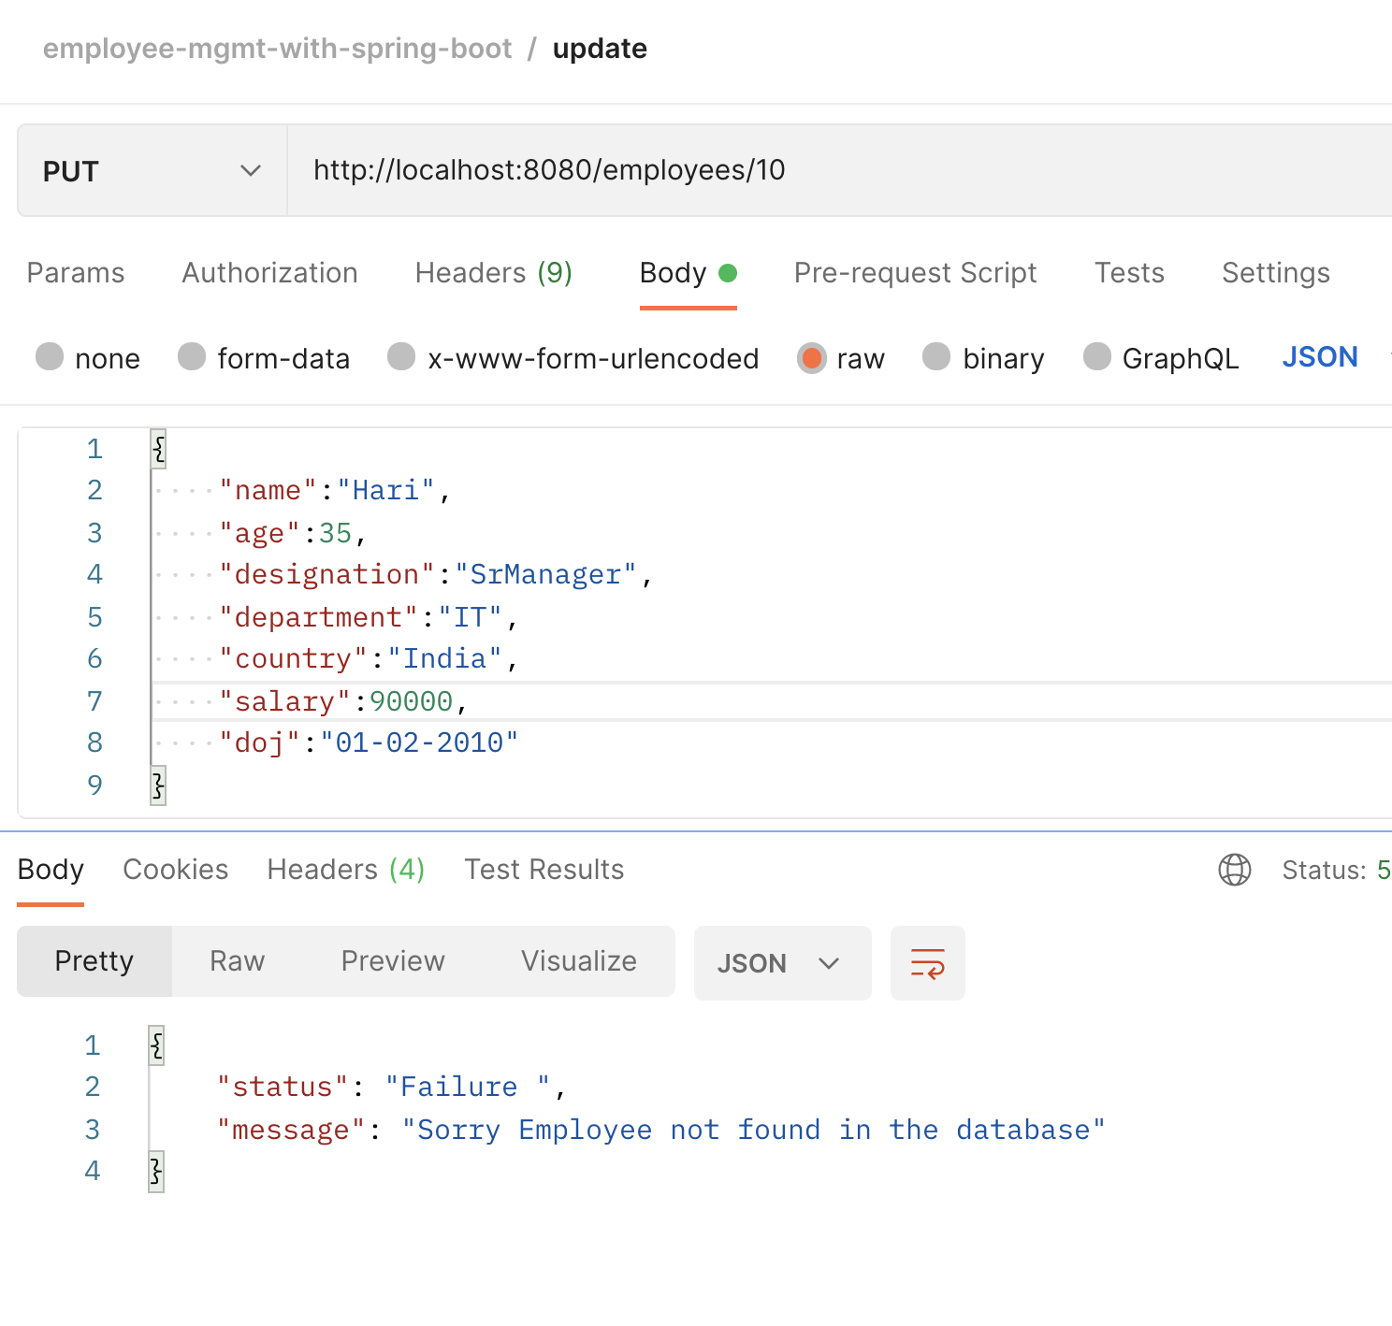

Delete employee

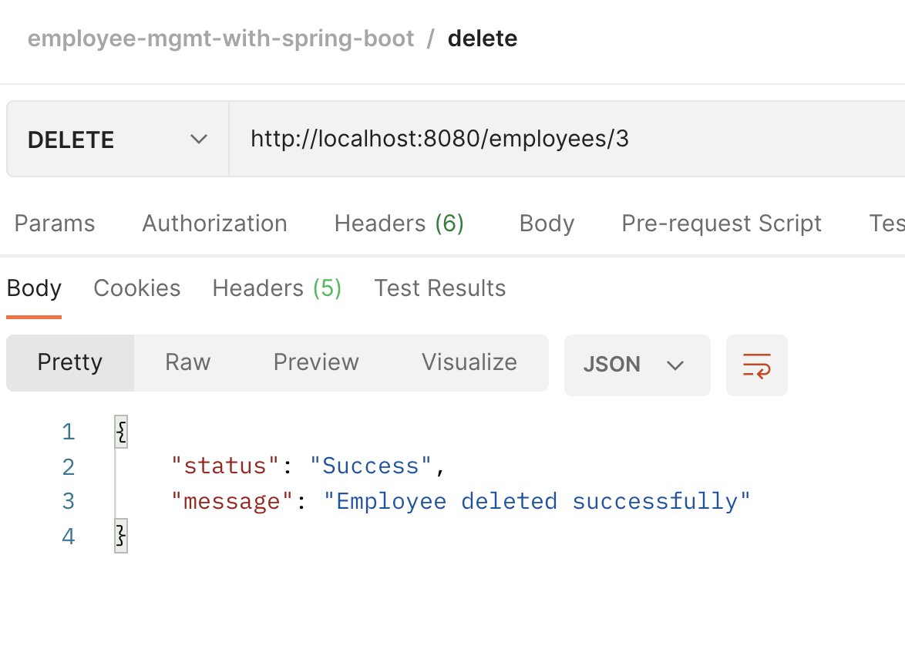

Exceptional Handling Del emp

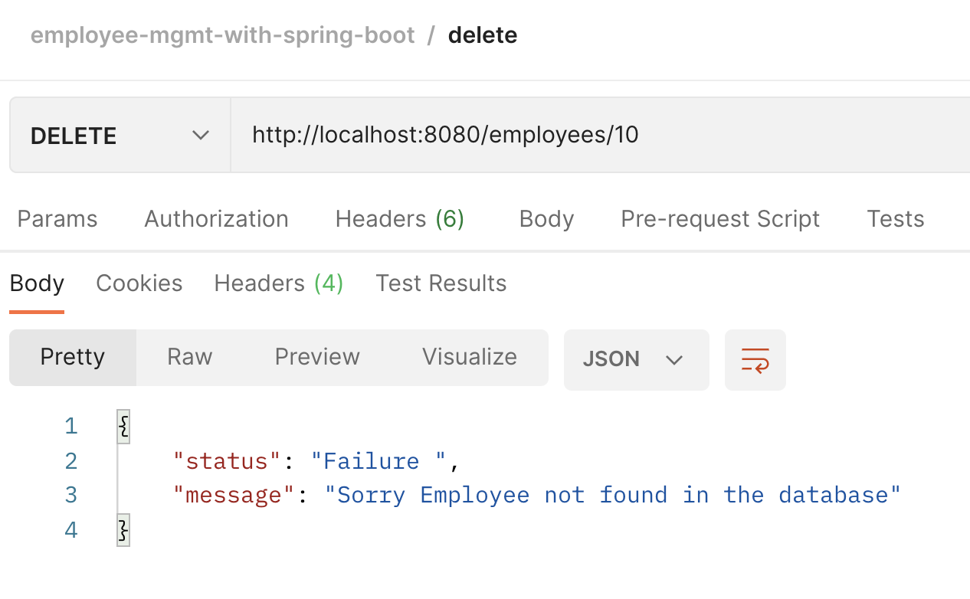

View all employees

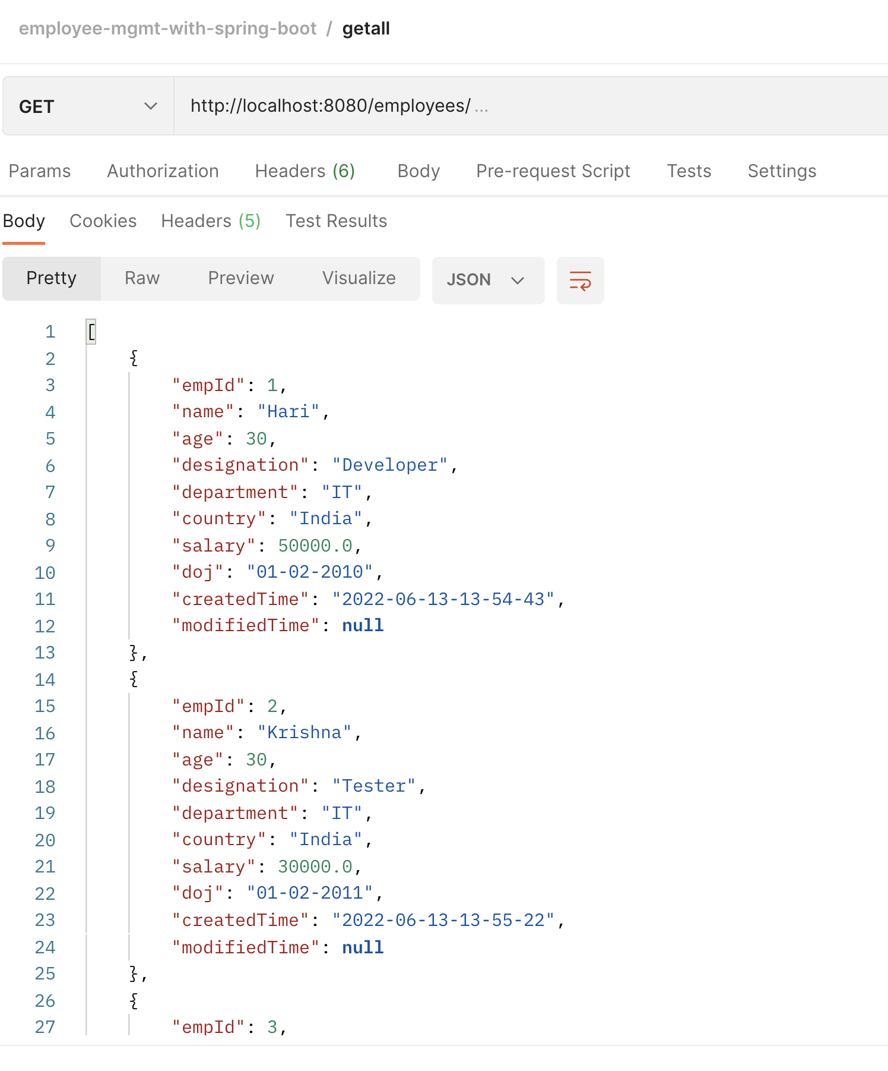

ExceptionalHandling if no Emp in the table

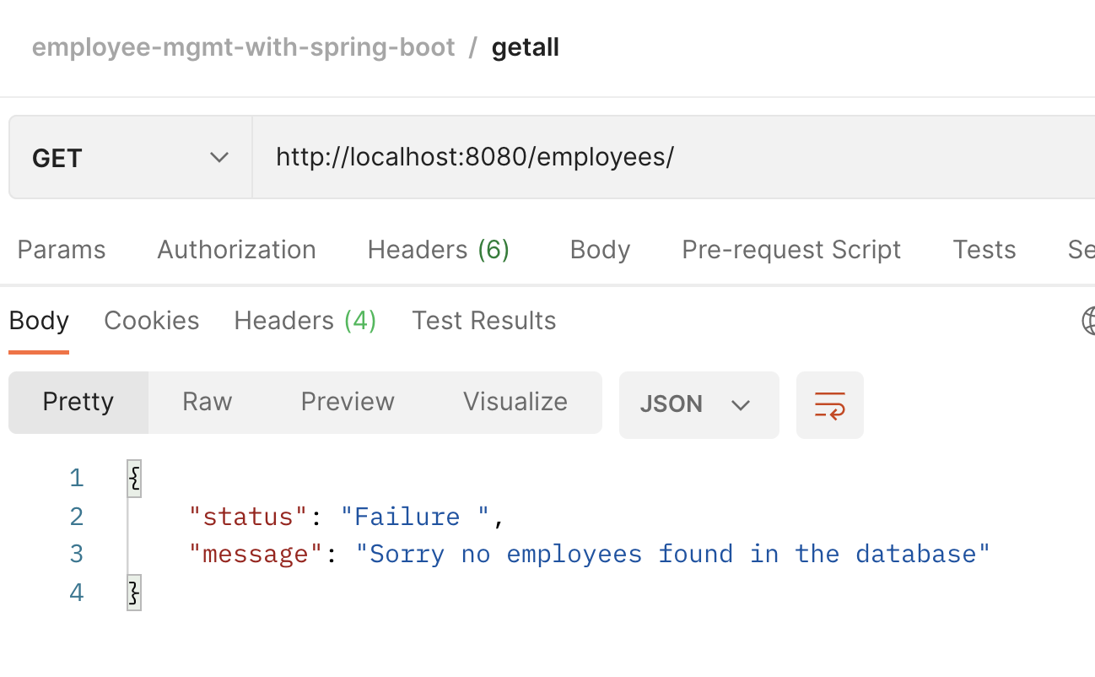

Database Exception

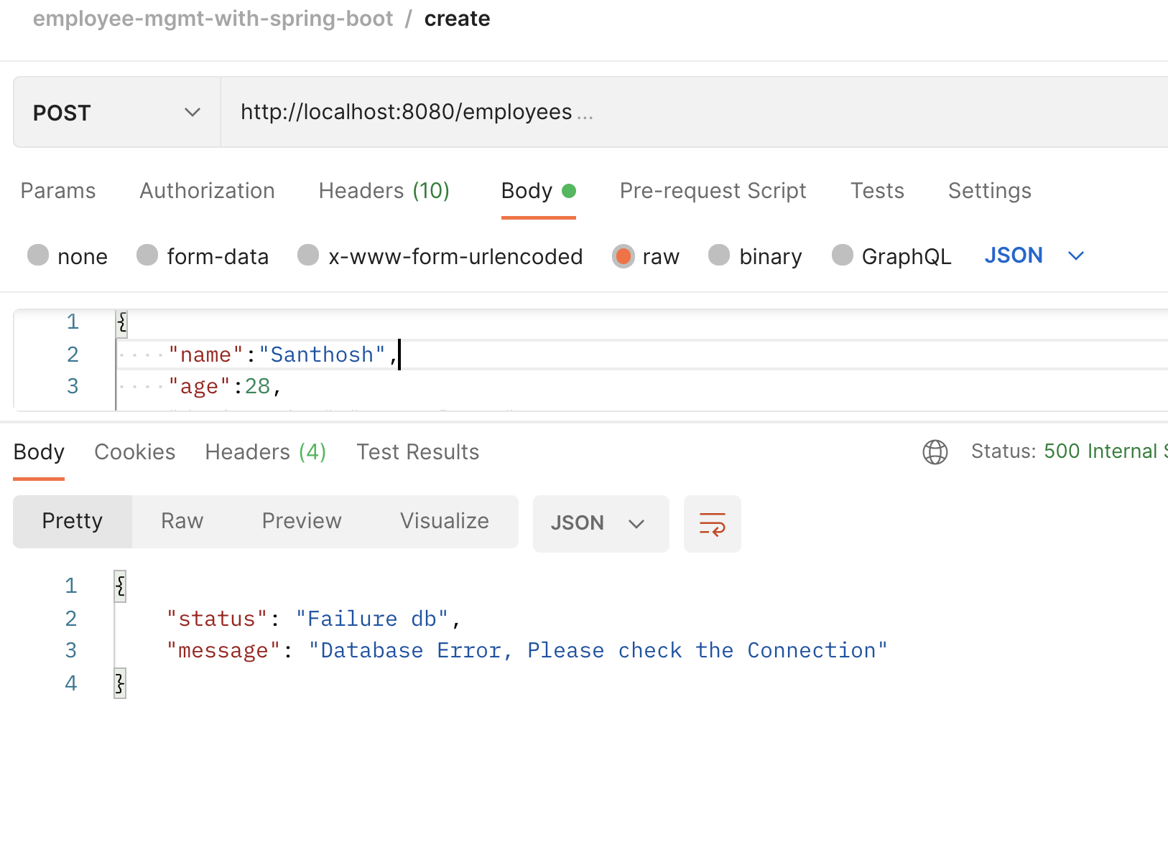

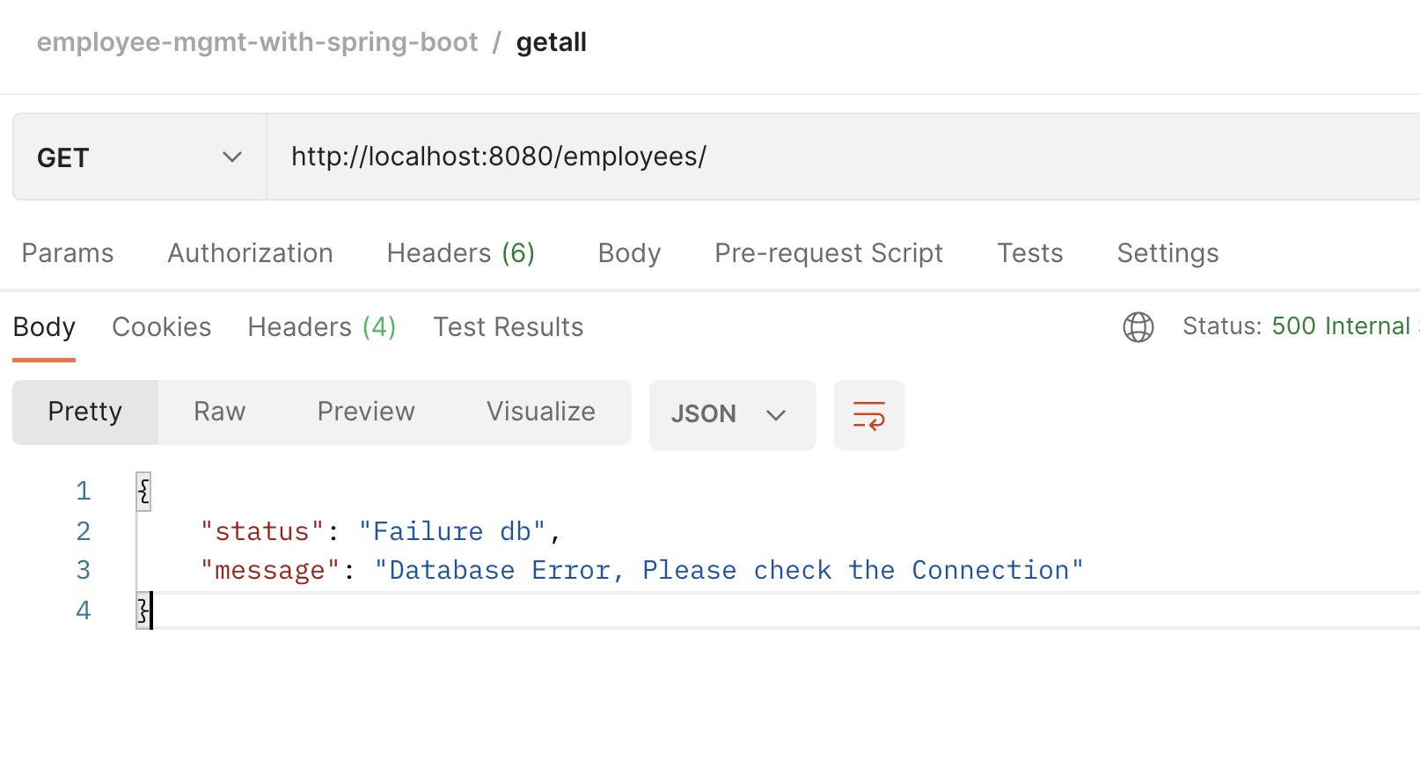

Content-Negotiation

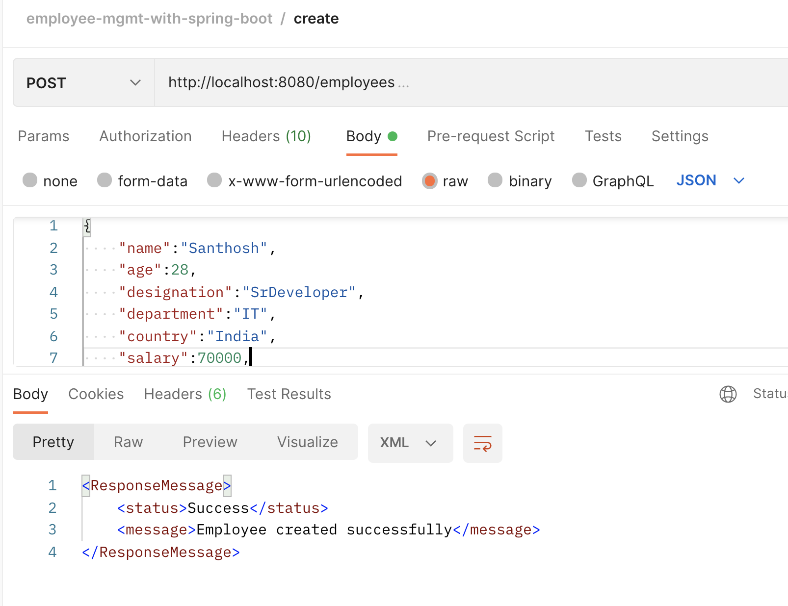

Logging

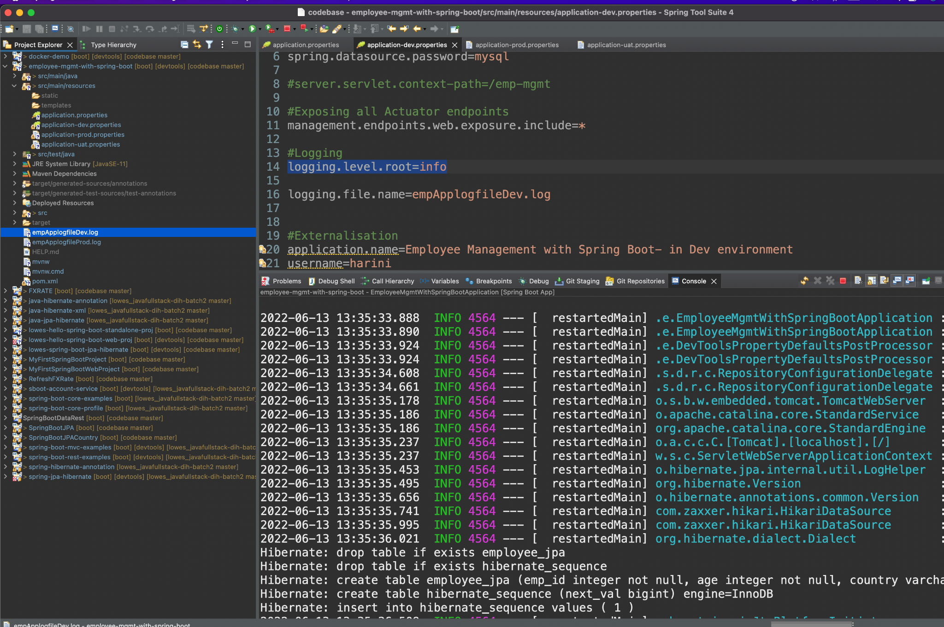

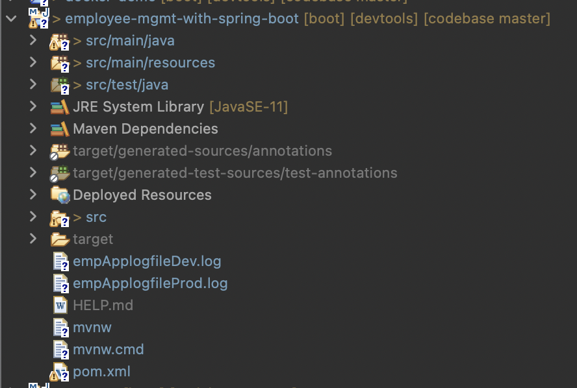

Externalized Configuration

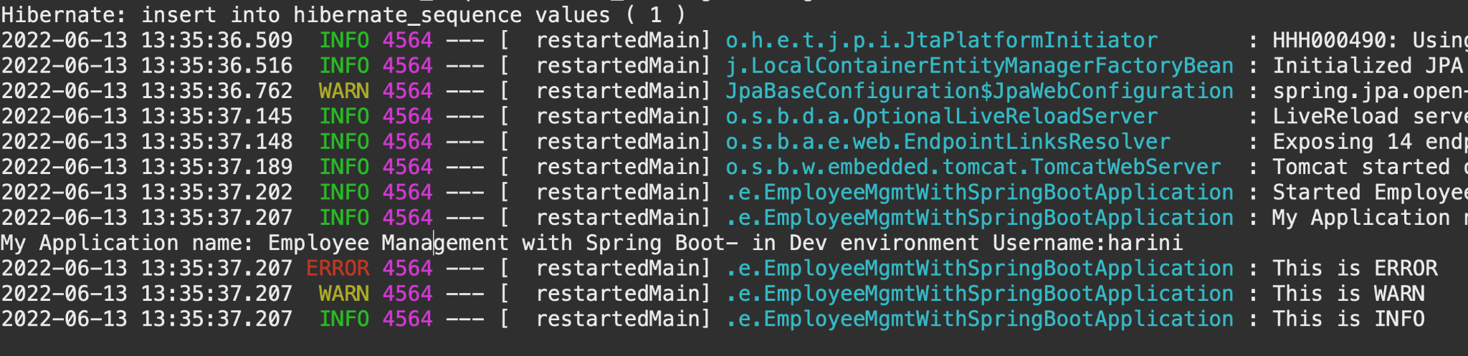

Profiling

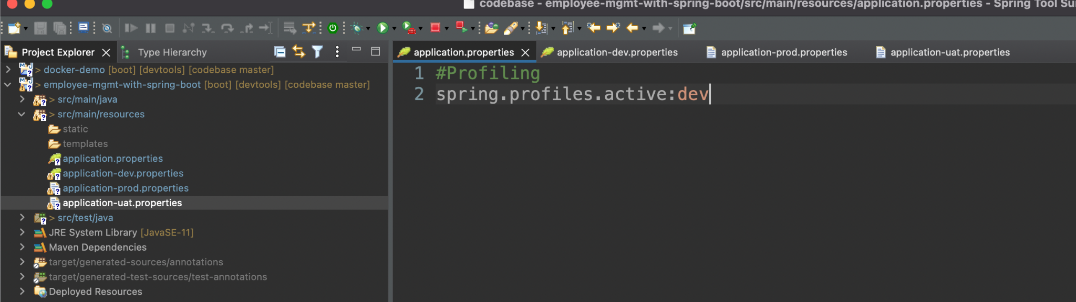

Actuator

